./

Learning Report – Module Name

Course Code: <CODE>



|  |  |  |  |  |  |
| --- | --- | --- | --- | --- | --- |
| **Ver. Rel. No.** | **Release Date** | **Prepared. By** | **Reviewed By** | **Approved By** | **Remarks/Revision Details** |
|  |  |  |  |  |  |
|  |  |  |  |  |  |
|  |  |  |  |  |  |
|  |  |  |  |  |  |
|  |  |  |  |  |  |

**Document History**

# 

Table of Contents

Checklist 4

Activity and Tasks 4

**Activity 1**– System/Software Development 4

1. Requirement 4

2. Design 6

3. Test Plan 9

**Activity 2** –CI Workflow for C Programming 11

2.1 CI /CD 11

**Activity 3** – Agile Aspects 13

3.1 Requirement Mapping: 13

3.2 Test plan requirement: 13

3.3 User Stories 14

# Checklist

* Installation of SW on Phone and Desktop
* Additional Aspects …

# Activity and Tasks

## **Activity 1**– System/Software Development

Sun Tracking Solar Panel

### 1. Requirement

Topic: Sun Tracking Solar Panel

#### 1.1 Ageing:

The amount of electricity that is obtained is directly proportional to the intensity of sunlight falling on the photovoltaic panel. Hence there is a need for tracking sunlight. A typical solar panel converts around 30 to 40 percent of incident radiation into electrical energy. In paper “Optimum tilt angle and orientation for solar collector in Brunei Darussalam”, the optimum angle was computed by searching for the values for which the total radiation on the collector surface is a maximum for a particular day or a specific period. The results reveal that changing the tilt angle 12 times in a year.

In the article “An Optimum Slope Angle for Solar Collector Systems in Kerman Using a New Model for Diffuse Solar Radiation”, the monthly average daily diffuse solar radiation on a horizontal surface is calculated first, using 12 new hybrid models. A standard isotropic model is then used to estimate the global solar radiation on inclined surfaces. Finally, the monthly, seasonal, and yearly optimum slope angles to gain the maximum global solar radiation are suggested.

In early 2000 effective solar energy harness was done using mirror reflection later 2009 the effective method was tilting the panel periodically by considering the intensity of sun light. So the effective method for tilting or rotating the solar panel should be done using microcontroller for automating the rotation of solar panel with the help of servo motor.

Table 1: Cost Gradation

|  |  |  |
| --- | --- | --- |
| SL no | Product | Cost estimation |
| 1 | Single Axis Vertical, Single Axis Tilted, Single Axis Horizontal | INR 10,000 |
| 2 | Dual axis solar tracker | INR 75,000 |
| 3 | Solar tracking system | INR 8,700 |

From the table 1 the cost estimation for various sun trackers was found. As in the early days orientation of solar panel and surface area was the specific matter of concern for harness of energy.

By using the automated sun tracker the high price requirement of hardware is reduced with the best quality and high efficient.

#### 1.2 Proposed method

The two LDR’s are placed at the two sides of solar panel and the Servo Motor is used to rotate the solar panel. The servo will move the solar panel towards the LDR whose resistance will be low, mean towards the LDR on which light is falling, that way it will keep following the light. And if there is same amount of light falling on both the LDR, then servo will not rotate. The servo will try to move the solar panel in the position where both LDR’s will have the same resistance means where same amount of light will fall on both the resistors and if resistance of one of the LDR will change then it rotates towards lower resistance LDR.

#### 1.3 SWOT analysis:

Strength:

• The tracking is automated.

• The hardware requirement is reduced

• Efficient energy harness

Weakness:

• Tracking system covers large area.

• Energy is harnessed only during sunshine.

Opportunity:

• Number of panel’s requirement is reduced

• Installation of sun tracking system in agriculture requirement

Threats:

• Improper site selection may cause interference

• Due to complex design and implementation process, it will be difficult to attract investors and project developers.

#### 1.4 Detailed requirement

High level requirements

• Achieving maximum solar energy by proper inclination.

• Single panel with large surface area can be rotated to 180(two LDR) or 360 (four LDR) .

• Setting the initial condition of servo motor

Low level requirements

• LDR’s with large surface area is more sensitive to light intensity and the resistance decrease which actuates servo motor.

• Servo motor rotates towards the LDR with low resistance hence the maximum solar energy is trapped.

• Servo motor initial voltage set 5V.

### 2. Design

#### 2.1 Low level behavioral design use case diagram

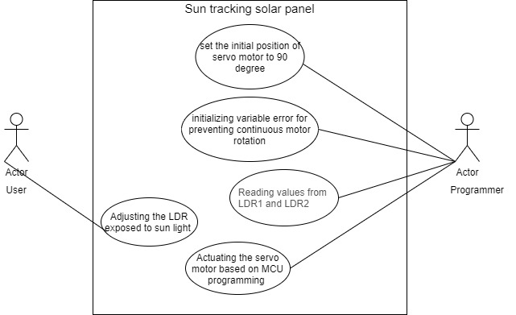

#### 2.2 Low level behavioral design Activity diagram

#### 2.3 High level behavioral design use case diagram

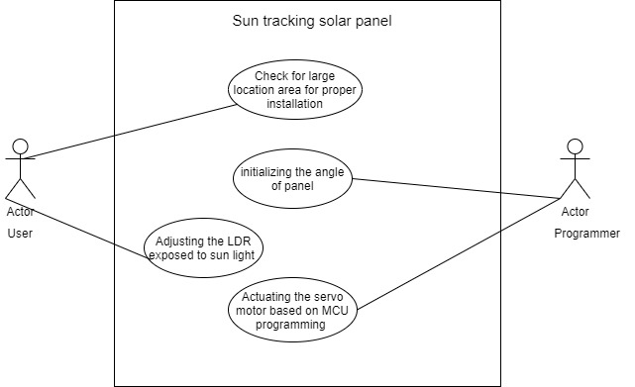

#### 2.4 High level behavioral design activity diagram

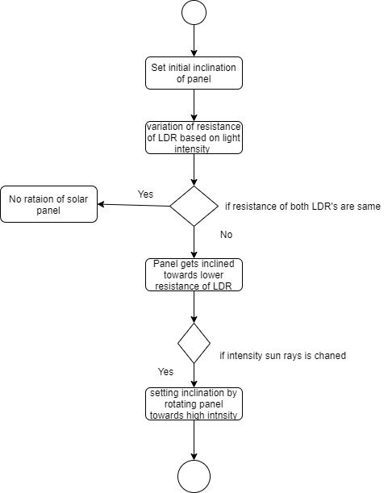

#### 2.5 Low level structural design composite diagram

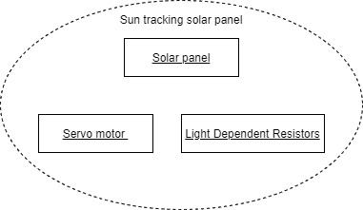

#### 2.6 Low level structural design component diagram

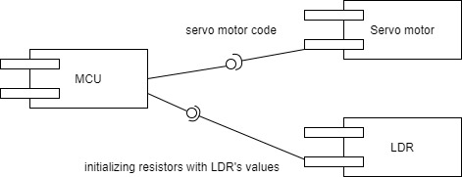

#### 2.7 High level structural design component diagram

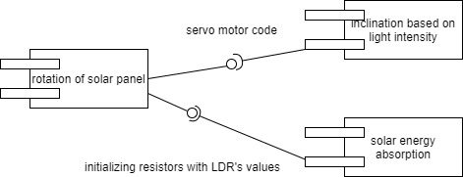

#### 2.8 High level structural design composite diagram

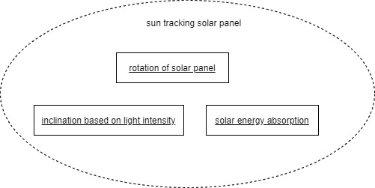

### 3. Test Plan

#### 3.1 Requirement Based Test Plan

• Arduino recommended input voltage is from 7 to 12 volts but you can power it within the range of 6 to 20 volts which is the limit

• Positive wire of the battery to the Vin of the Arduino and the negative wire of the battery to the ground of the Arduino.

• Connect the positive wire of the servo to the 5V of Arduino and ground wire to the ground of the Arduino and then connect the signal wire of Servo to the digital pin 9 of Arduino.

• Connect one end of the LDR to the one end of the 10k resistor and also connect this end to the Analog pin of the Arduino and connect the other end of that resistor to the ground and connect the other end of LDR to the 5V.

• The voltage is 5v input to servo motor and actuated based on LDR resistances

• The error variable will be used to set the threshold value ,as the resistance differences is below the error value then do nothing.

• Setting initial inclination to 90 degree

#### 3.2 Scenario Based Test Plan

• If the voltage applied to MCU is above 20V the MCU is damaged hence the rotation of the servo motor is affected

• If the LDR used is of small surface area then the variation in resistance is affected hence the rotation of panel is affected

• As the number of LDR used is increased .i.e. 4 LDR’s one in each edge. The Panel rotates 360 degrees.

#### 3.3 Boundary Condition based test plan

• As maximum limited voltage of 20V is applied on MCU the requirement of the circuitry is maintained without affecting the circuitry.

• As the voltage is set to 5v boundary value 5v with will not affect the current scenario.

## **Activity 2** –CI Workflow for C Programming

### 2.1 CI /CD

**Calculator**

Requirements

High Level Requirements

* Calculation of many operation to be performed using keypad with many symbols
* Parameters can be put input with two parameters.
* Finding the number odd or even, prime or not.
* To Find the math operations
* Conversion from one form to another

Low level Requirement

* Find addition, subtraction, multiply, division of given two inputs
* Parameter that the function take two or one based on function declaration.
* The inputted two numbers are to be check even or odd ,prime or not
* Finding reverse, palindrome and square
* Converting kilometer to meter, kilometer to centimeter and kilometer to millimeter.

UML diagram

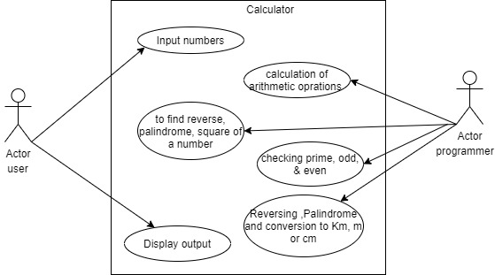

Test Plans

|  |  |
| --- | --- |
| ID | Description |
| H01_L01 | Calculation of operations done using keypad and perform addition, subtraction, multiply, division of given two inputs |
| H02_L02 | Parameters can be put input with two parameters and Parameter that function take two or one based on function declaration. |
| H03_L03 | Finding the number odd or even, prime or not by input variables |
| H04_L04 | Finding math operations like reverse, palindrome and square of a number |
| H05_L05 | Conversion from one form to another .i.e. Converting kilometer to meter, kilometer to centimeter and kilometer to millimeter. |

Test Cases

|  |  |  |  |  |  |
| --- | --- | --- | --- | --- | --- |
| ID | Description | precondition | Expected input | Expected  output | Actual  output |
| add | Finding addition of two numbers | User as to input the value | A=10  B=20 | 30 | 30 |
| subtract | Finding subtraction of two numbers | User as to input the value | A=0  B=3 | -3 | -3 |
| multiply | Finding multiplication of two numbers | User as to input the value | A=1  B=0 | 0 | 0 |
| divide | Finding multiplication of two numbers | User as to input the value | A=1  B=0 | 0 | 0 |
| greater | Finding greater of two numbers | User as to input the value | A=10  B=20 | 20 | 20 |
| smaller | Finding smaller of two numbers | User as to input the value | A=10  B=20 | 10 | 10 |
| prime | Finding prime or not | User as to input the value | A=7 | 1(true) | 1 |
| Even  Or  odd | Finding odd or even | User as to input the value | A=6 | 1 | 1 |
| Factorial | Finding factorial of a number | User as to input the value | A=5 | 120 | 120 |
| Square area | Finding area of square | User as to input the value | A=5 | 25 | 25 |
| Square perimeter | Finding perimeter | User as to input the value | A=5 | 20 | 20 |

Git CI/CD:

Repository link: <https://github.com/99002499/Task_Calculator>



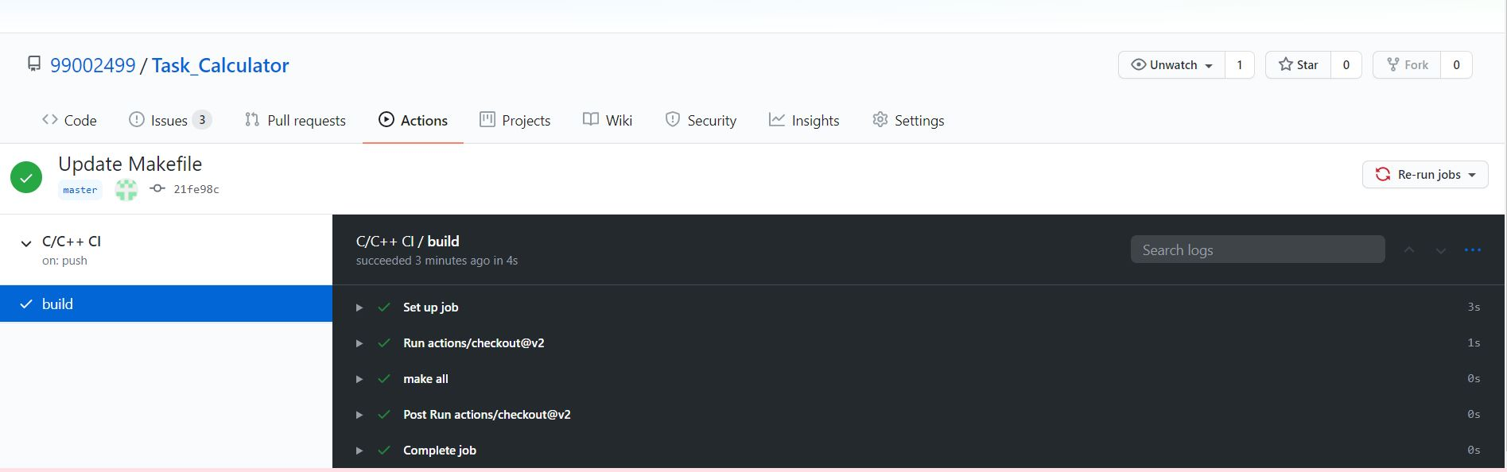





## **Activity 3** – Agile Aspects

### 3.1 Requirement Mapping:

|  |  |
| --- | --- |
| ID | Description |
| H01_L01 | Achieving maximum solar energy by proper inclination with initially set with 90 degree by LDR’s with large surface area is more sensitive to light intensity and the resistance decrease which actuates servo motor. |
| H02_L02 | Single panel with large surface area can be rotated to 180(two LDR) or 360 (four LDR) by Servo motor rotating towards the LDR with low resistance hence the maximum solar energy is trapped. |
| H03_L03 | Setting the initial condition of servo motor by Servo motor initial voltage set 5V. |

### 3.2 Test plan requirement:

|  |  |  |  |  |  |
| --- | --- | --- | --- | --- | --- |
| ID | Description | precondition | Expected input | Expected  output | Actual  output |
| IDsg90 | Initial inclination | Initial inclination is set to vertical (90 degree) | Sg90 input pin is assigned with 90 degree | Panel inclined vertically | If not 90 degree as initial the LDR is not properly exposed to light |
| LiDere2 | Setting the LDR’s at the edges of panel | Fixing the LDR’s and its values are assigned as input | High intensity on LDR which has resistance low and assigned as input to R1 & R2 | The difference of R1 and R2 is set to above 5 | Below 5 difference  The remains stationary |
| Serinit0 | Setting the requirement of servo motor | Initial voltage to setting up servo motor is 5V | Arduino V0 pin outputs 5v and the motor is set active | Servo responding to the R1 and R2 values | As the voltage is below 5v the servo does not rotate panel |

### 3.3 User Stories

As an solar panel installer,

I want solar panel to be of minimum size and weight. The sun tracker must be highly efficient to respond to the change in the intensity of light as the sun moves from west to east.

So that due to less area occupied by the solar tracker it will be easy to fix in any electric power station or even in agricultural area for maximum renewable energy utilization.

As an household user,

I want the tracker to be mobile and the size , weight constraint to considered .The energy trapped by the panel can be used to charge household appliances like solar bulb ,solar heater etc.

So that solar tracker being mobile I can keep inside the house at night and during day time solar tracker will be exposed to sun light.

As an industrialist,

I want sun tracker to rotate over 360 degree and solar panel with large area to capture maximum amount of sunlight .As the amount of energy absorbed is directly proportional to electrical energy obtained after conversion electrical energy also increases to maximum.

So that large machineries used in the industry makes use electrical energy obtained for power up and maintain its work based on the requirement.

Appendix

Link: <https://github.com/stepin104475/Fact>





